Let’s hack the solitaire!

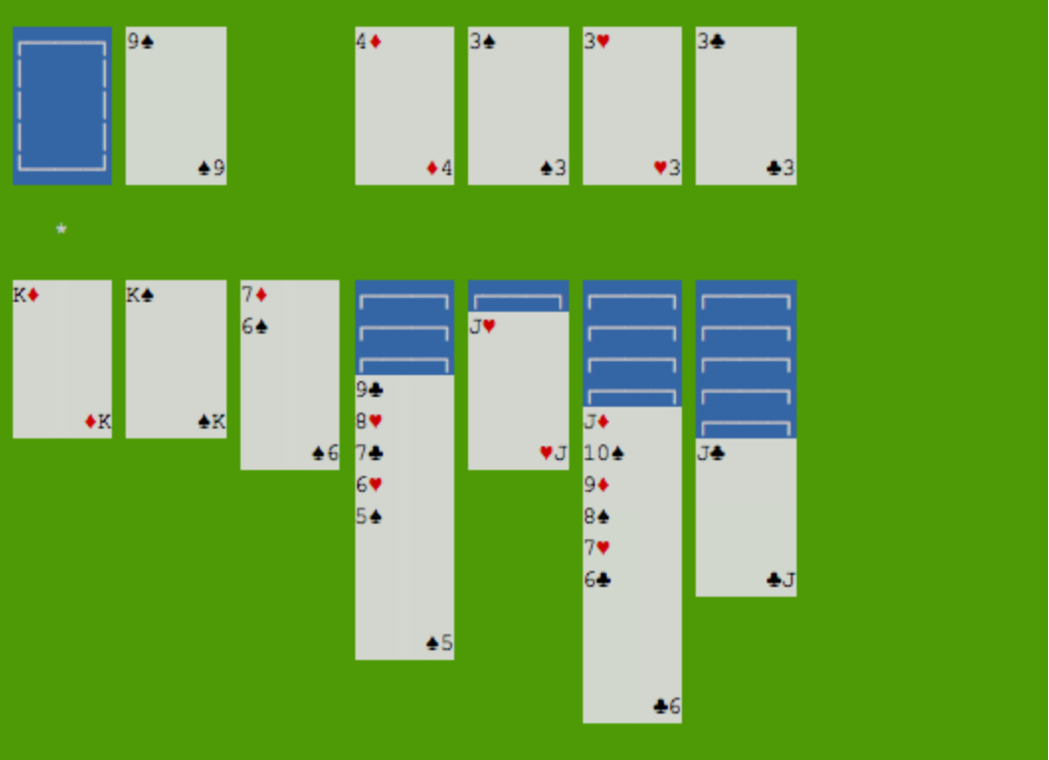

The goal of the challenge is to always have the same initial hand!

To install, open terminal in the folder and run

sudo apt-get install libncurses5-dev libncursesw5-dev

make

(make install)